

DEPARTMENT OF COMPUTER & SOFTWARE ENGINEERING
COLLEGE OF E&ME, NUST, RAWALPINDI

Subject Name: Data Structures

Project Report

SUBMITTED TO:
Lab Instructor: Ma’am Anum

SUBMITTED BY:
Mueed Rauf
Talha Arshad
M. Taha

DE- 44, syn. A Dept. Computer and Software Engineering

Submission Date: 06/03/2024

PROJECT REPORT

I. Abstract …………………………...…………………………………………………… [Page 3]

II. Introduction ……………………...………………………………………………….... [Page 3]
A. Project overview ……………………………………………………………….. [Page 3]
- Introduction……………………………………………………………[page 3]
- Components…………………………………………………………..[page 3]
B. Implementation details ………………………………………………………….. [Page 4]

III. Block Diagram ……………………….……………………………………………..[Page 4,5]

IV. Search Engine and proposed solution …………….……………………….……. [Page 5]
A. components ……………………………………………………………….. [Page 5]
- Fetching and pasrsing…………...……………………………[page 6]
- Indexing term and doc info…………………………………. .[page 6]
- Searching and Retrieving results………………………….…[page 6]

V. GUI ……………………………….…………………….……………………….……. [Page 6]

Project Title: Search Engine Desktop Application
Abstract:
The search engine shown in this project is made to index and look up text files inside of a given directory. To provide speedy search queries, the search engine makes use of a Trie (prefix tree) data structure for effective term storing and retrieval. Nodes in the Trie retain metadata relevant to each document, such as file locations and phrase frequency, which allows for more thorough indexing and ranking of search results. To further hone query results, the search engine also supports Boolean search operations (AND, OR). To improve the user experience, it also has navigation features for viewing document contents and navigating through previously seen documents. This project shows how to create a search engine that can handle both simple and complex search queries and has effective document management and data retrieval features.
Introduction
- Project Overview:
Introduction
This project implements a search engine, designed to index and search through text files within a specified directory. The search engine uses a Trie data structure to efficiently store and retrieve terms, ensuring quick and accurate search results.
Components
- Data Structures:
  - TrieNode: Represents a node in the Trie, containing child nodes, document frequency information, and connections to other documents.
  - DocInfo: Holds metadata about a document, such as the frequency of a term and the file path.
  - vertexNode: Represents a document in a graph structure, storing connections to other documents.
- Search Engine Functionality:
  - Indexing: The search engine reads through text files in a specified directory, extracting terms and storing them in the Trie. Each term is associated with document metadata, including the frequency of occurrence and the file path.
  - Search Queries: Users can perform search queries using individual terms or boolean operations (AND, OR). The search engine retrieves and ranks documents based on term frequency and supports caching of search results for faster subsequent queries.
  - Document Navigation: Users can view the content of indexed documents and navigate through previously viewed documents using back and forward operations.
- Boolean Operations:
  - AND Operation: Retrieves documents that contain all specified terms.
  - OR Operation: Retrieves documents that contain any of the specified terms.
  - Intersection and Union Functions: Implements the AND and OR logic by intersecting or uniting the results of individual term searches.
- File Handling:
  - The search engine scans a directory for text files, parses their contents, and adds terms to the Trie. It maintains a mapping between document IDs and file paths to facilitate content retrieval.
Implementation Details
- Trie Structure: Terms are stored in a case-insensitive manner within the Trie, with each node representing a character. Terminations of terms are marked using a boolean flag (isEndOfWord).
- Document Metadata: Each node in the Trie contains a map of document IDs to DocInfo structures, which store the term frequency and file path.
- Graph Structure: Documents are connected through a list of vertexNode structures, enabling graph-based operations to find related documents.
- Search and Navigation: The search engine supports complex queries, result caching, and document navigation to enhance user interaction.
Flow Chart Diagram:
The diagram shows the the flow of data and the control.

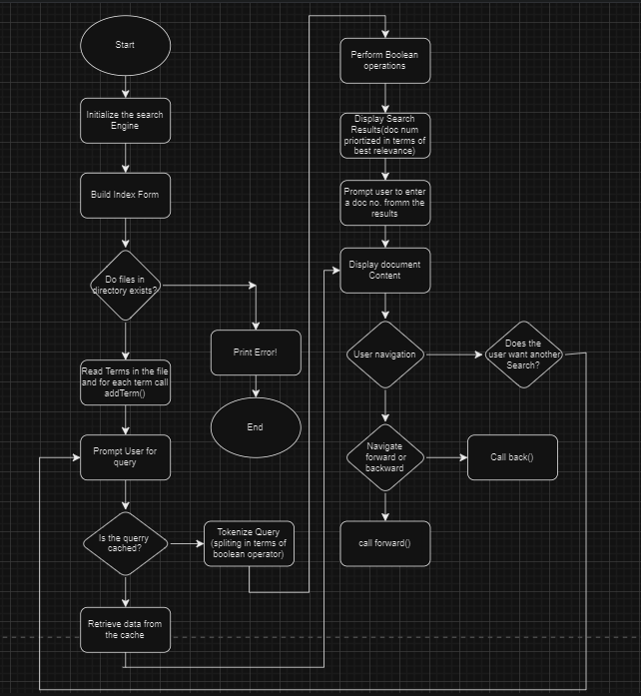

Search engine and our proposed Solution:
Search engine Components
A typical web crawler consists of three primary components:
- Fetching and Parsing Documents
- Indexing Terms and Document Information
- Searching and Retrieving Results
Our code implementation corresponds to these components and provides a solution to each part of the problem.
Part 1: Fetching and Parsing Documents
Explanation
The first step of a web crawler involves fetching documents from the web (or in our case, a local directory) and parsing their content to extract meaningful data. This process includes:
- Accessing the specified directory to locate text files.
- Reading the content of each text file.
- Extracting words/terms from the content.

Part 2: Indexing Terms and Document Information
Explanation
The second step is to index the terms found in the documents. This involves:
- Storing terms in a data structure for efficient retrieval.
- Keeping track of the frequency of each term in each document.
- Associating terms with their respective document IDs and file paths.

Part 3: Searching and Retrieving Results
Explanation
The final step involves searching for terms within the indexed data and retrieving relevant documents. This process includes:
- Processing search queries, which may involve boolean operators (AND, OR).
- Retrieving and ranking document IDs based on term frequency.
- Displaying document contents and enabling navigation through viewed documents.
At last it displays and have the ability to navigate through the opened foiles.

GUI:
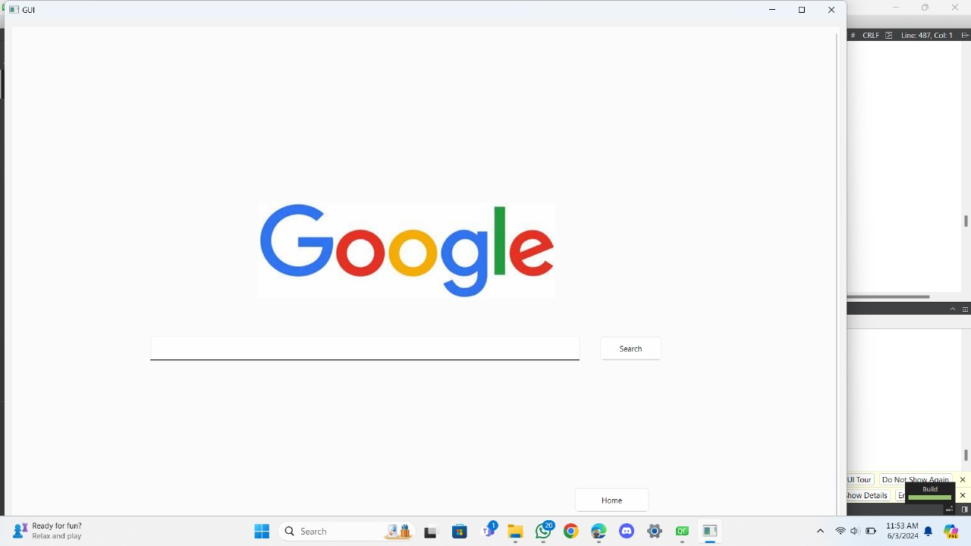
This is the front end, QT creator framework was used to make the front end.
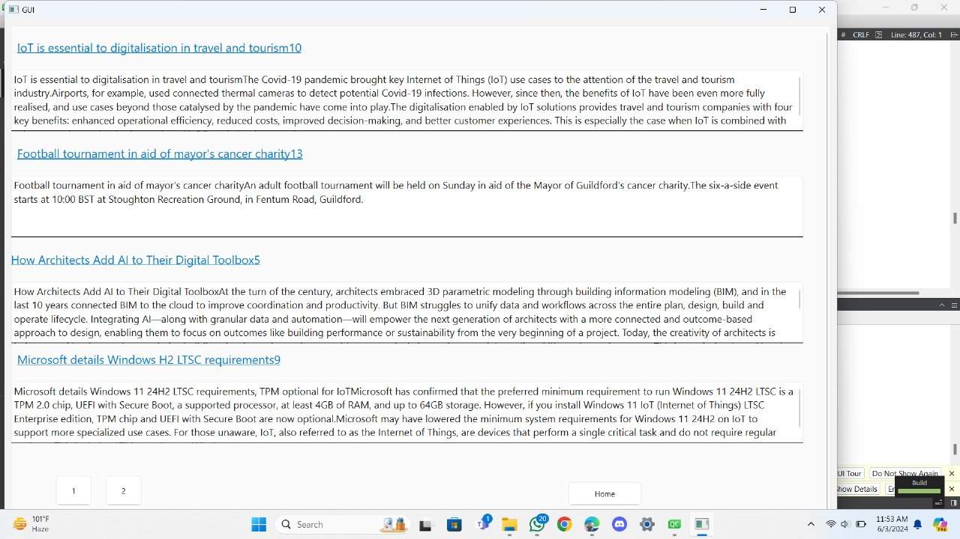
Search results

